Materials:
*1 skein worsted weight yarn (I use Hobby Lobbys I Love This Yarn!)
if doing the contrasting band 2 skeins in the colors you choose
* I hook and a K hook
* A large eye yarn needle for weaving in ends
*Pom-pom maker (homemade maker works well here too, I use a homemade on roughly 4.5 inches across)
*scissors
*a smileeeeeeee :)
Stitch Explanation:
Sc:Single crochet
Ts:Trinity stitch as follows...chain 1, insert hook into same stitch and pull up a loop, insert hook into next stitch and pull up a loop x2, yarn over and pull through all 4 loops on the hook
Because I am new to pattern writing and because some of my personal techniques may be different than traditional methods of crochet I have included painfully detailed photographic instruction. This is to ensure we are “on the same page” with our stitches and to help new crocheters, or those new to this stitch, be successful ….
A video tutorial on this hat can be found here on You Tube :)
Please join me over in a new facebook group called Crochet Supernova .....
Now smile and grab your yarn and hook :) Let's have some fun!!!!!
The band:
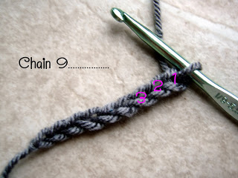
With your I hook and your band color chain 9
Row 1: insert hook in the 2nd chain from the hook and sc all the way across, ch 1 turn
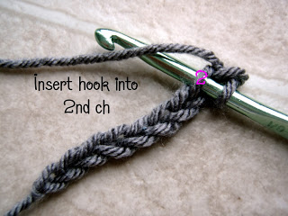
Row 2: insert hook in back loop only and sc across all (8 sc st)
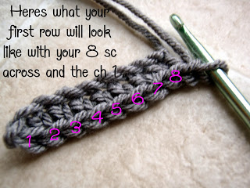
*my counting may look different than yours so I have numbered the stitches*
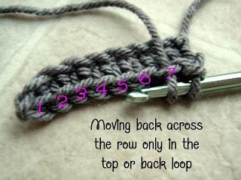
Repeat row 2 until you have a total of 62 rib rows making up the band.
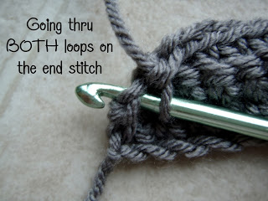
Chain 1 and turn on side single chain in each stitch across the LENGTH of the band until you reach the final stitch.
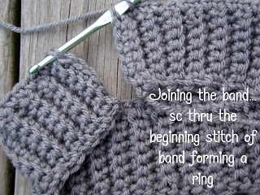
Joining the Band:
Bring band around joining the ends. Inset hook into last stitch going through the last row and first row of the band at the same time. Draw up a loop and sc through BOTH joining the two ends forming the band circle.
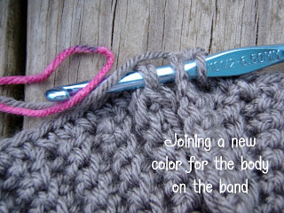
(I have switched yarn colors for the body of the hat so this is the time to do that as well if you care to, or simply continue in the band color)
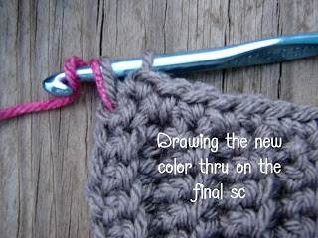
Chain 1 do not turn.

Note: Switch to your K hook here
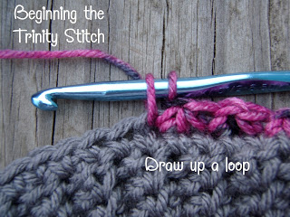

Body of the Hat:
Here is where you will begin your trinity stitch. Begin working in the round.
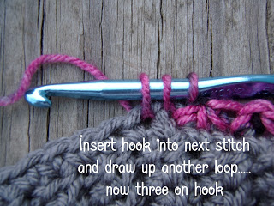
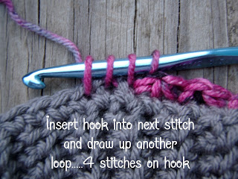Trinity Stitch in each sc around ending at he beginning with your last stitch ending in the first stitch of the beginning trinity stitch. DO NOT CHAIN just continue working in the round working in the stitches of the trinity stitches in the previous row.
Work the trinity stitch for 12 rounds
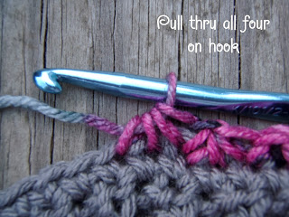

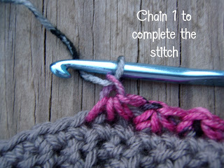
Decreasing the hat:
When you reach 12 trinity stitches high, or twelve rounds, begin to decrease the trinity stitch 4 stitches at a time. Do four normal trinities, then work a decrease as follows:
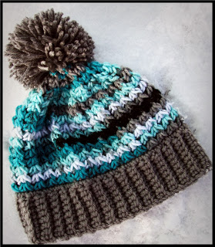Begin stitch as normal going into stitch just worked, skip next two stitches and go into 3rdst (this will be the top of a trinity cluster)and continue to work the stitch as normal pulling up a loop, inserting into the next stitch and pulling up a loop, yarn over and pull through all 4 loops, chain 1. Continue with 4 normal trinities, one decrease trinity stitch until you have roughly 35 or so chain spaces left , or about a palm sized opening left in the top of the hat. Sc in each stitch around, fasten off with an 8 inch tail for closing the hole.
Weave in and out of the sc in the top of the hat with your yarn needle, draw up tight with needle on the inside of the hat and tie off snugly weaving in end.
Use long tail left on the band of the hat to join the seam from the inside of the hat. Tie off snugly, weave in ends.
Using your pom pom maker make a super fun and fluffy pom. Attach FIRMLY to top of hat tying long ends on inside and weaving in tails.

